INSTALLATION OF SQL SERVER WITH SERVICE PACK 4

Depending on the operating system:

Standard edition of SQL (Windows 2000 and above os)

Step 1:

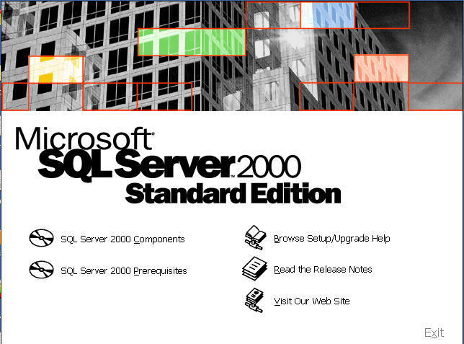

Select the first option to install SQL server and components on your machine.

Step 2:
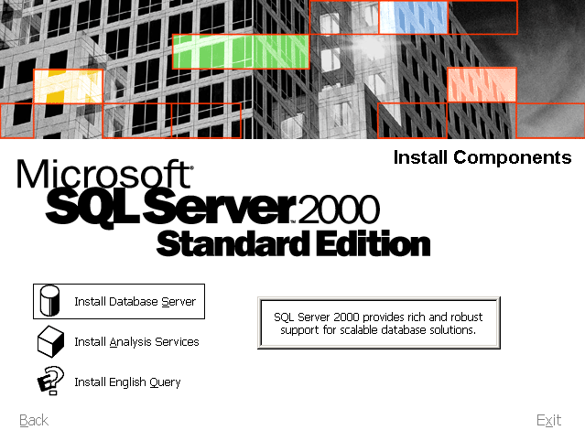

Select the install database server option.

Step 3:

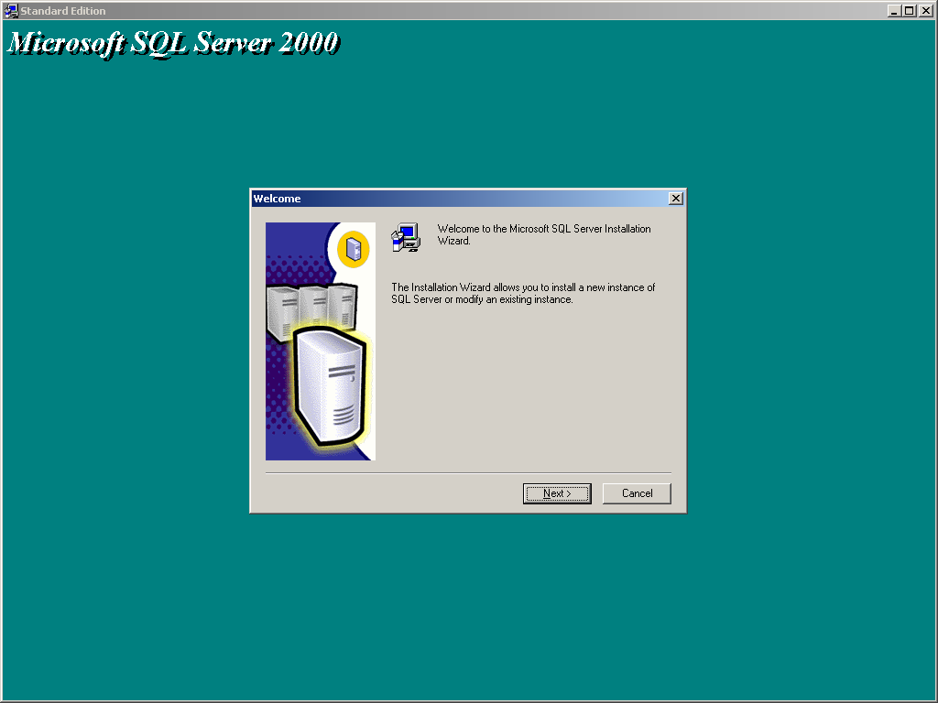
Welcome to the Microsoft SQL server installation. The installation wizard allows you to install a new instance of SQL server or modify an existing instance. Click on next to continue.

Step 4:

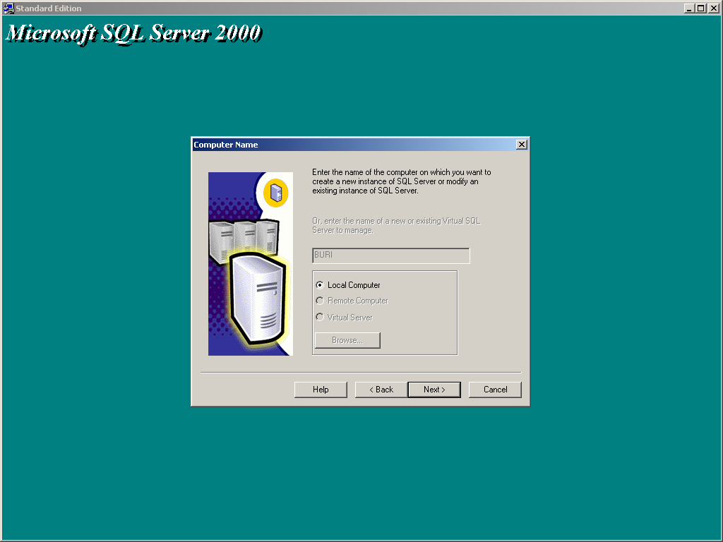
Enter the name of the computer on which you want to create a new instance of SQL server or modify an existing instance of SQL server. Click on next.

Step 5:

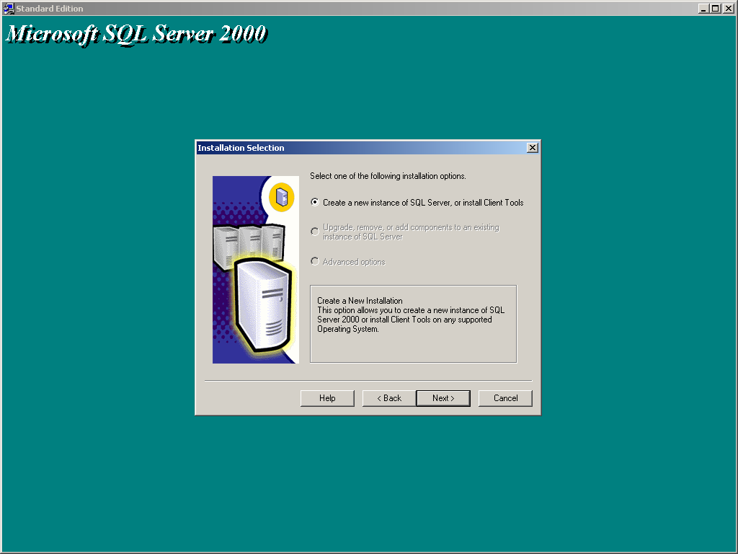

To create a new instance of SQL server, select create a new instance of SQL server, or install client tools. Create a new instance of SQL server 2000 or install client tools on any supported operating system.

Step 6:

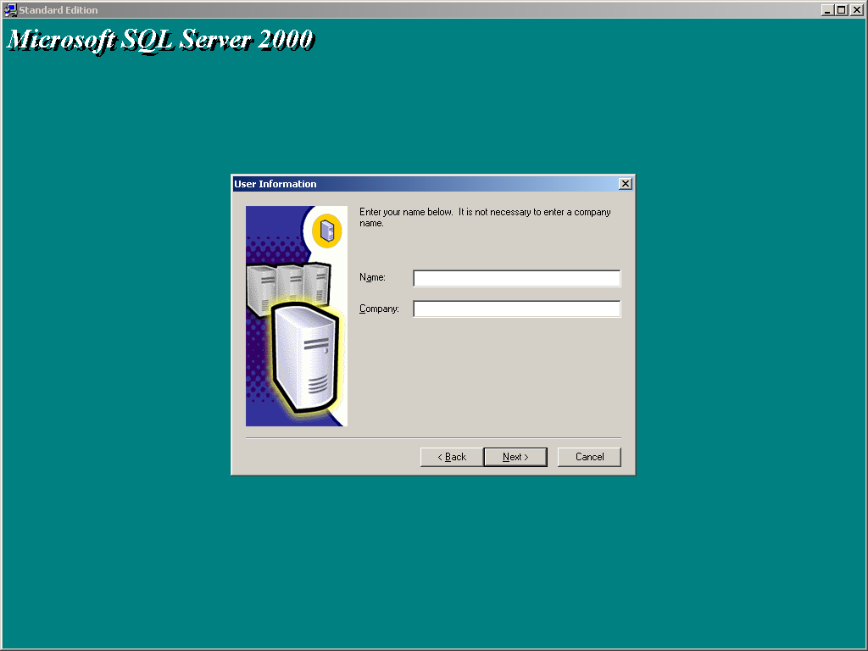

Enter your name above. It is not necessary to enter a company name. Click on next.

Step 7:

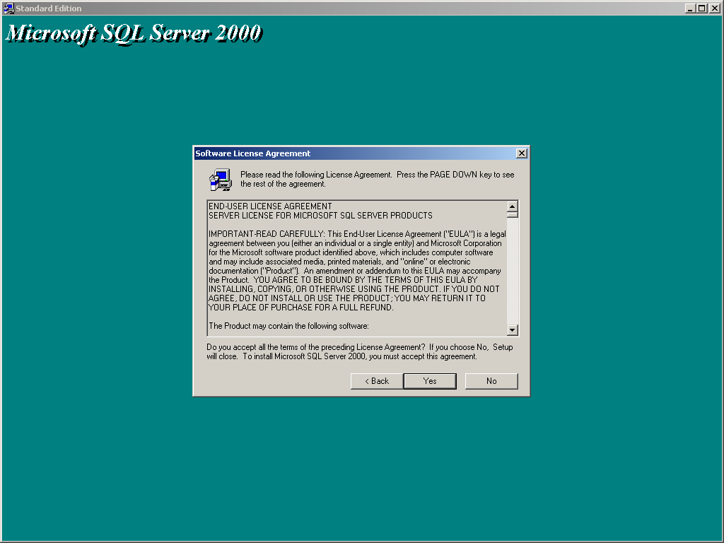

Please read the license agreement. Press the page down key to see the agreement. Do you accept all the terms of preceding license agreement? If you choose no, setup will close. To install Microsoft SQL server 2000, you must accept this agreement.

Step 8:

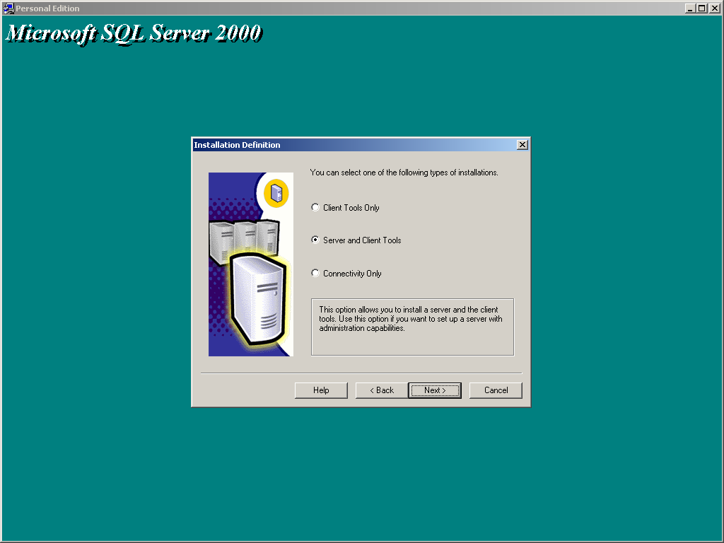

You can select one of the following types of installation:

- Client tools only.
- Server and client tools.
- Connectivity only.

Step 9:

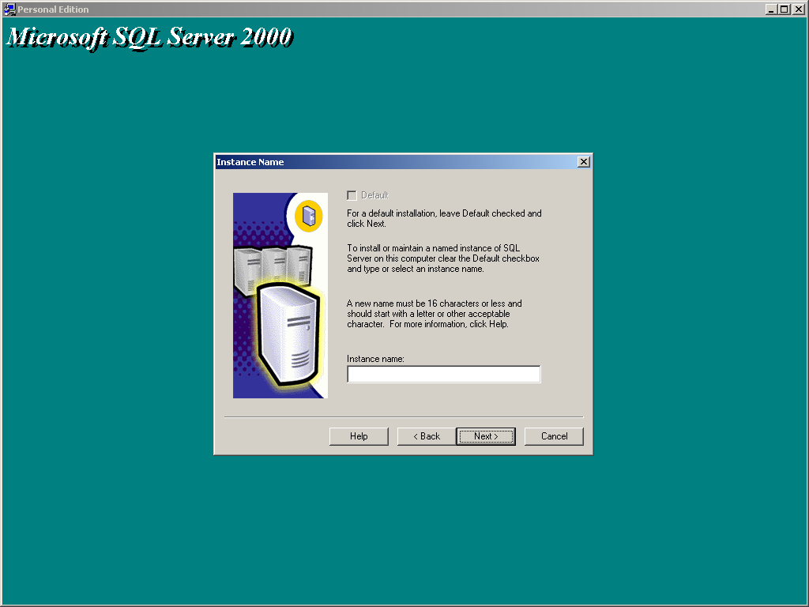

For a default installation, leave default checked and click next. To install or maintain a named instance of SQL server on this computer, clear the default check box and type or select an instance name.

Step 10:

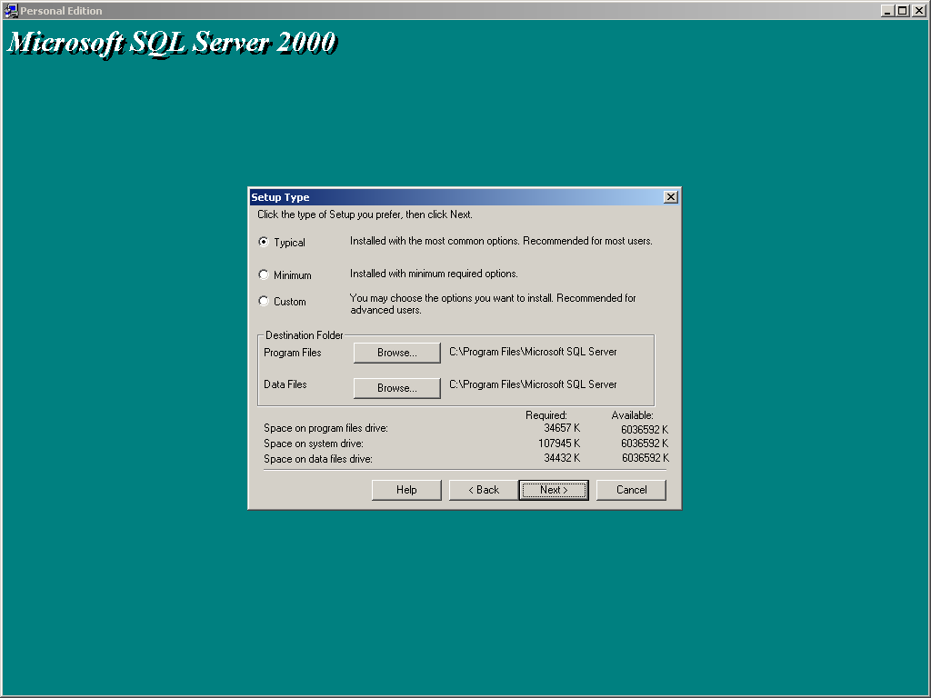

Click the type of setup you prefer, and then click on next.

- Typical.
- Minimum.
- Custom.

Step 11:

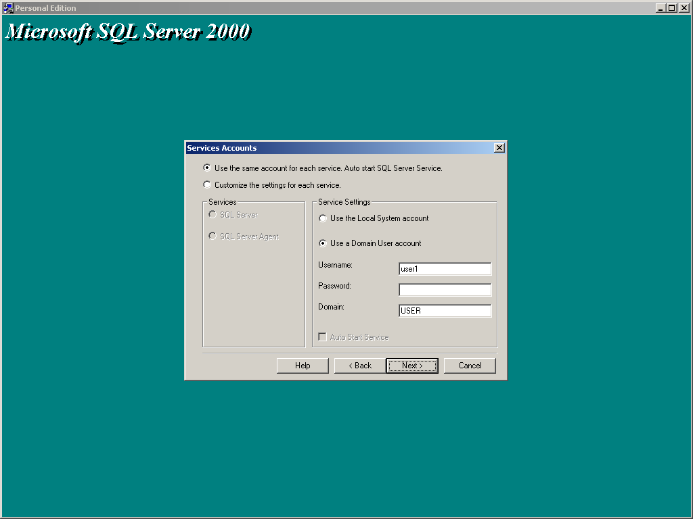

Select the service account. Use the same account for each service, auto start SQL server service. For the service settings, you can choose either local system account or a domain user account.

Step 12:

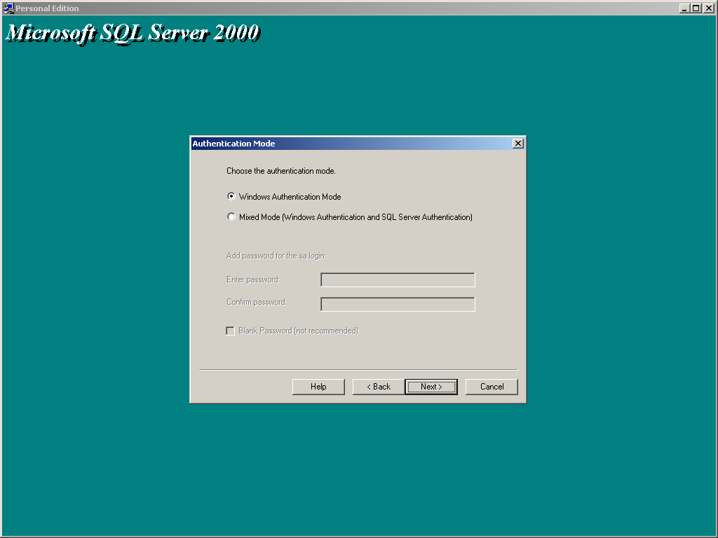
Choose the authentication mode, windows authentication mode or mixed mode (windows authentication and SQL server authentication).

Step 13:

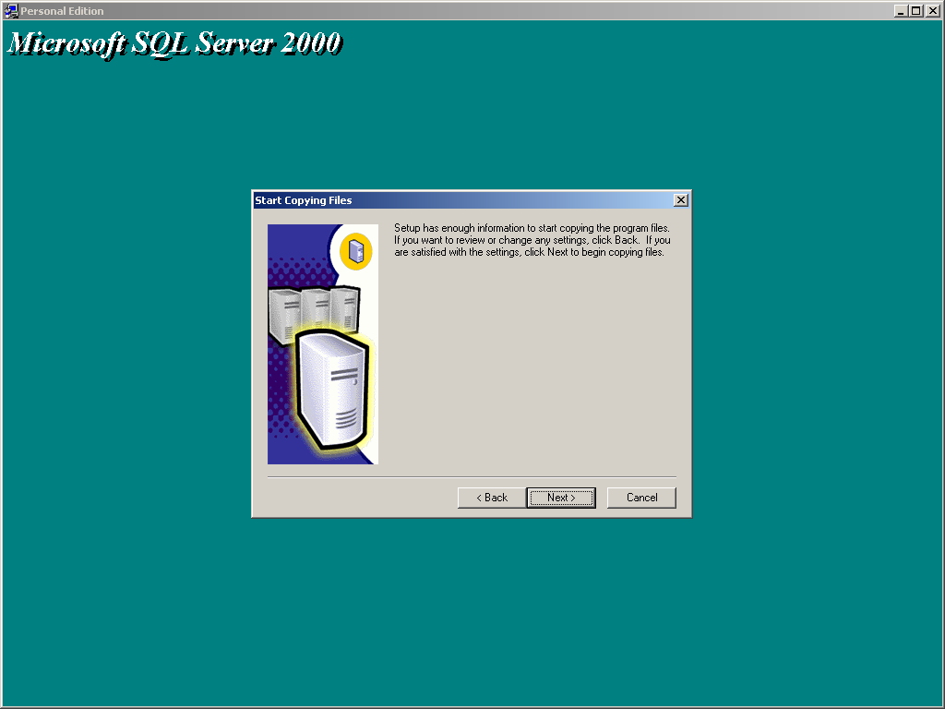

Setup has now enough information to start coping the program files. If you want to review or change any settings, click back. If you are satisfied with the settings, click next to begin copying files.

Step 14:

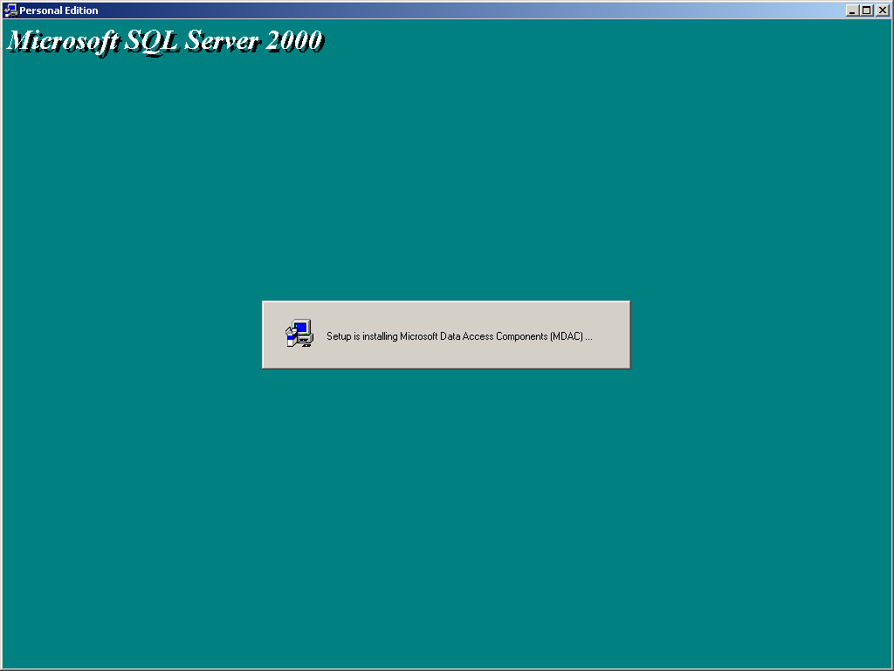

The above screen is displayed when files are being installed.

